**Experimentation and Results**

We have tested our program for the following test cases -

1. **Normal operation of the chat client with three clients connected**

For this use case, we have 3 clients (user1, user2, user3) in a group chat connected to the server.

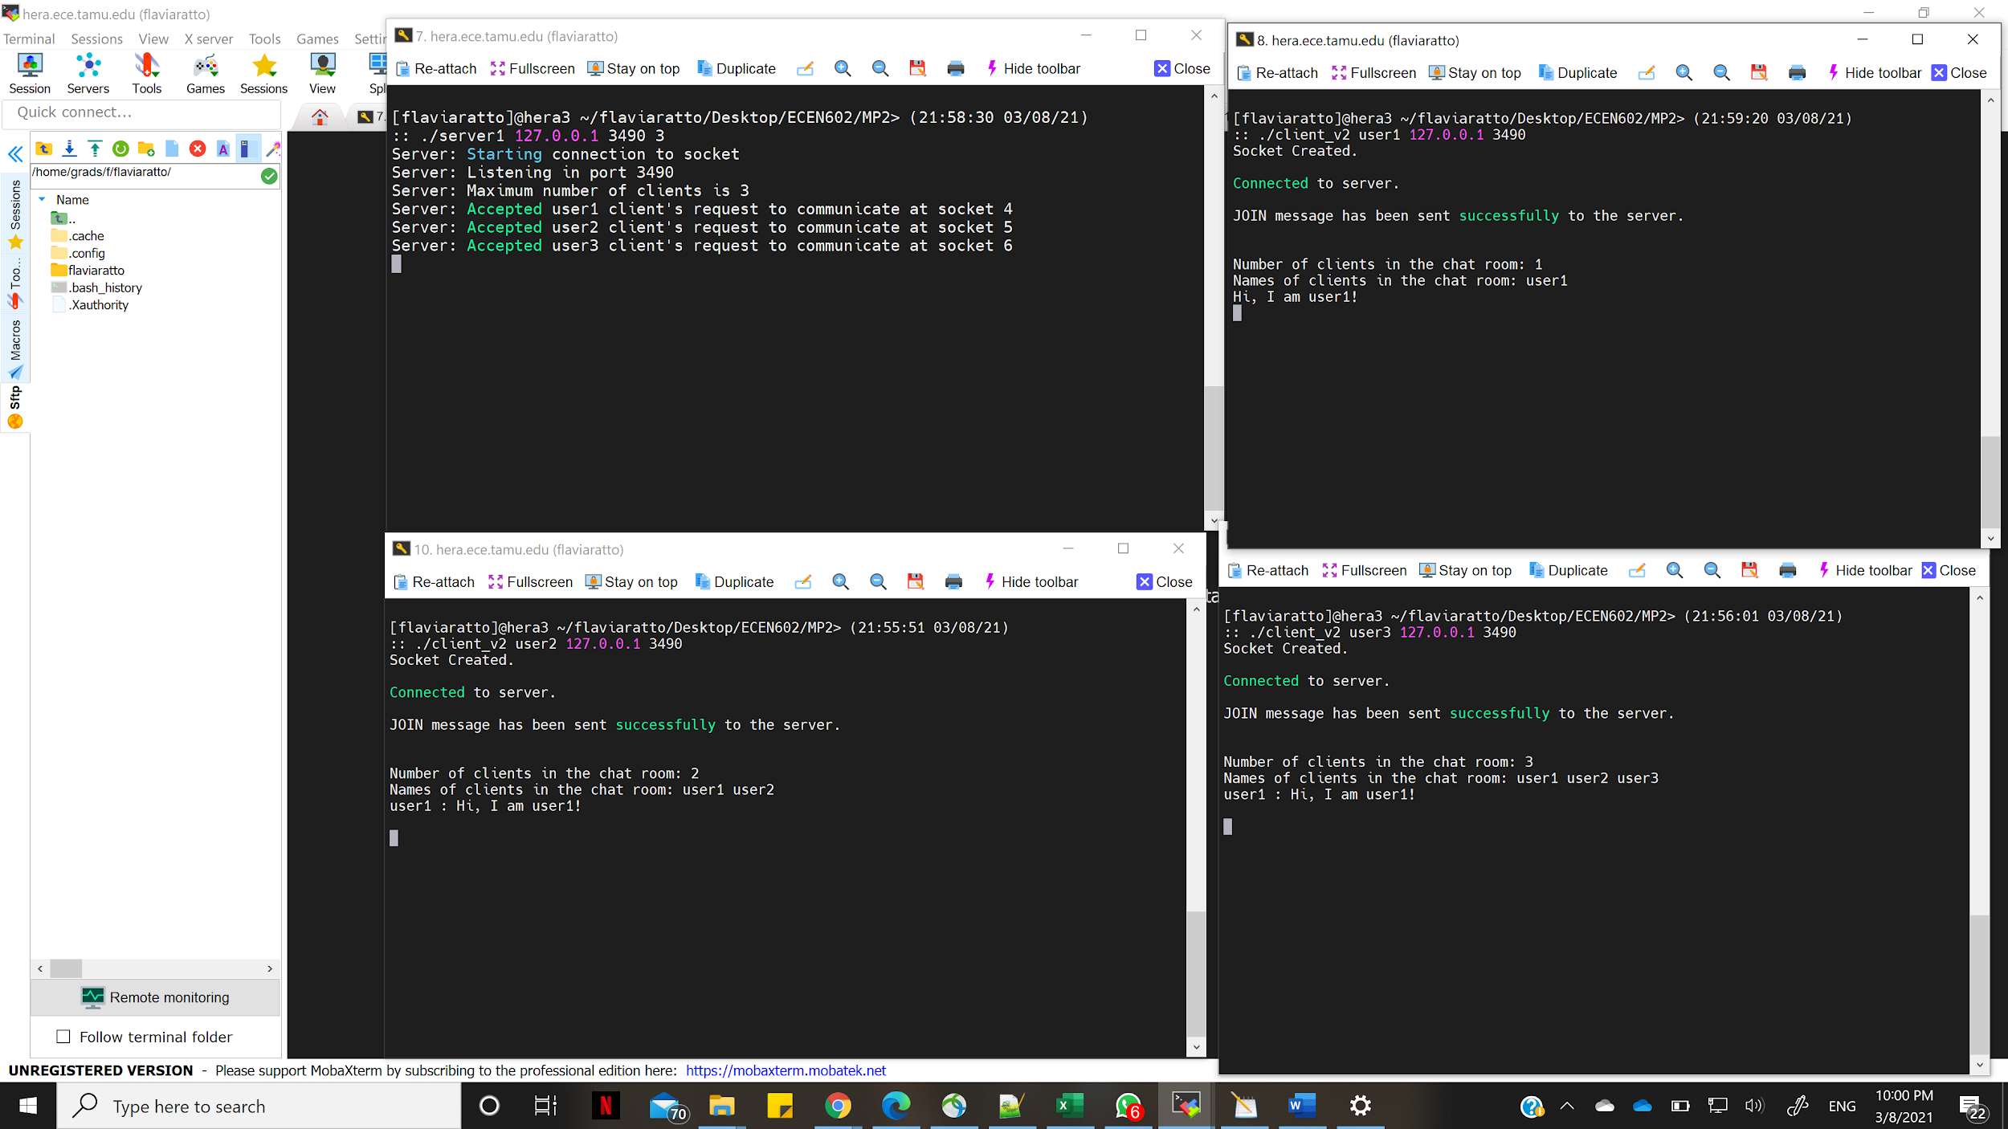

1. **Server rejects client with duplicate username**

In this use case, when the group chat already has user1 and user2. If a third client with the name user1 tries to enter the chat, it results in an error and the client has to try with a different username.

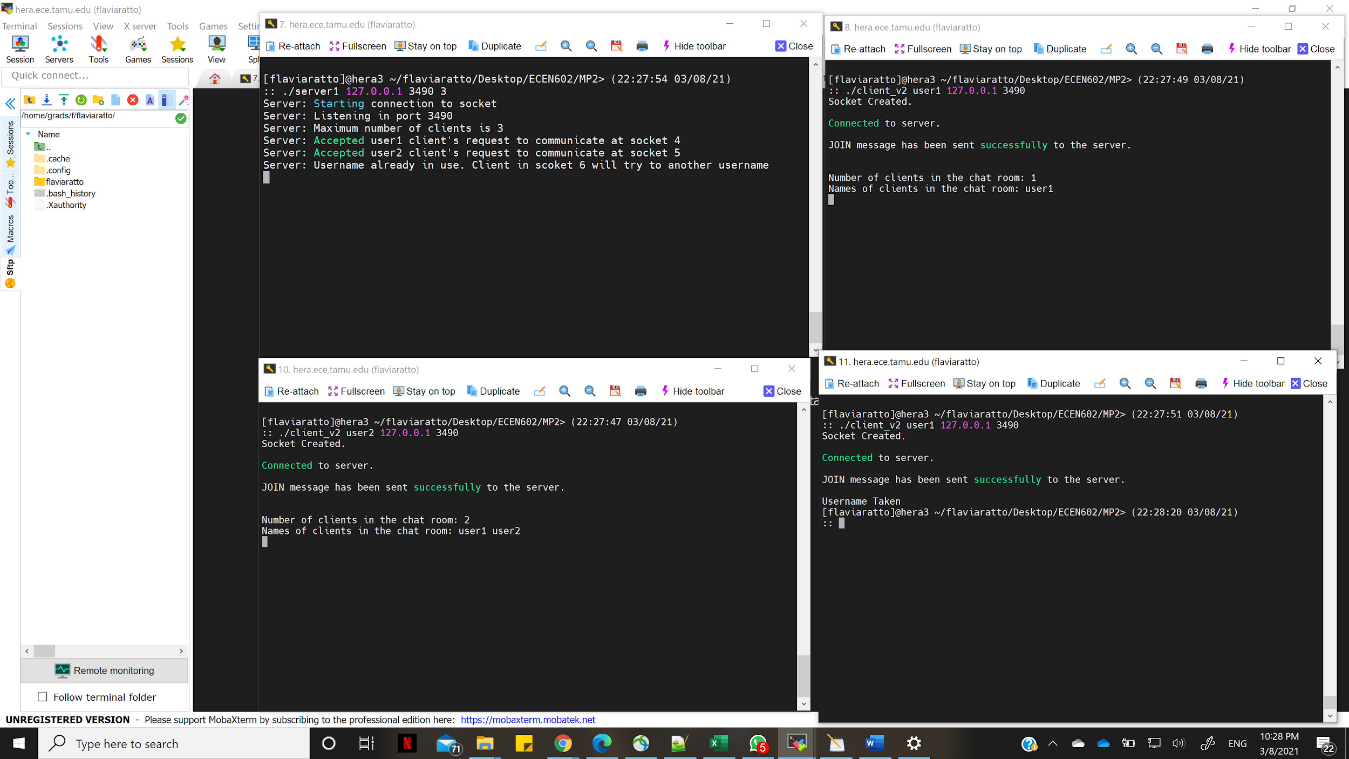

1. **Server allows a previously used username to be reused**

In this use case, we had user3 exit the group chat and then have another client try to join the chat with the username user3. We see that the server allows this.

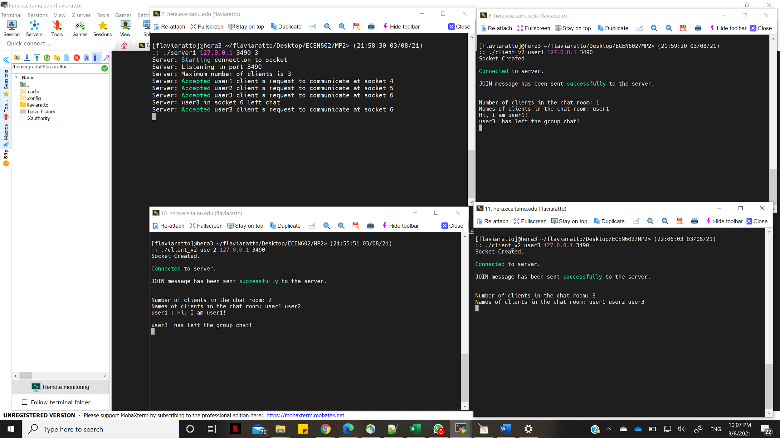

1. **Server rejects the client because it exceeds the maximum number of clients allowed**

In this use case below, the server has maximum connections allowed = 2. If a third client joins the server, they get an error stating “Chat room full” and the socket is closed.

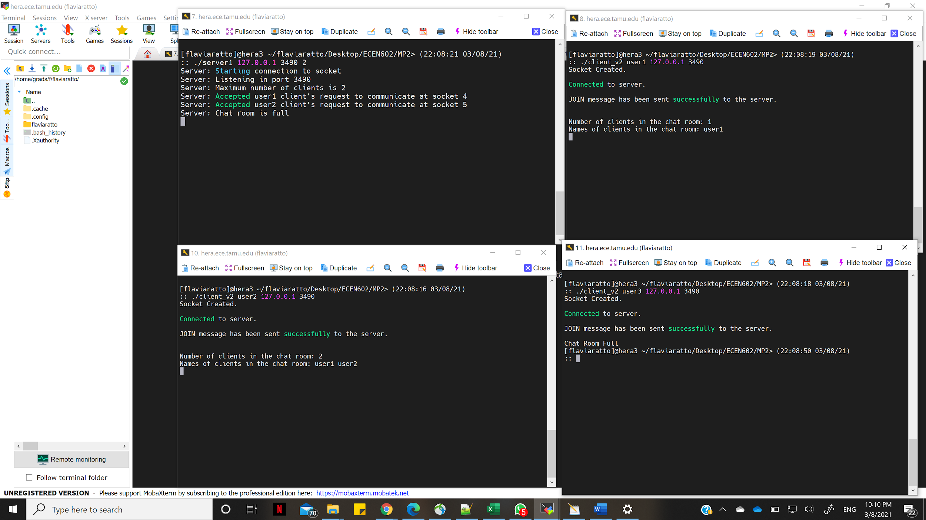

1. **All clients are notified when one client leaves the group chat.**

We also see that when a client, say user2, leaves a group chat, all the members in the chat (user1 and user3) are notified.

